**IBM-NALAIYA THIRAN PROJECT  
ASSIGNMENT 1 – Smart Home**

| 718019L113 – DINESHKANNA B R  718019L138 – SREEHARI KRISHNAKUMAR  718019L148 – VIDHYA V  718020L415 – SHRIMATHI T |
| --- |

**Circuit Diagram:**

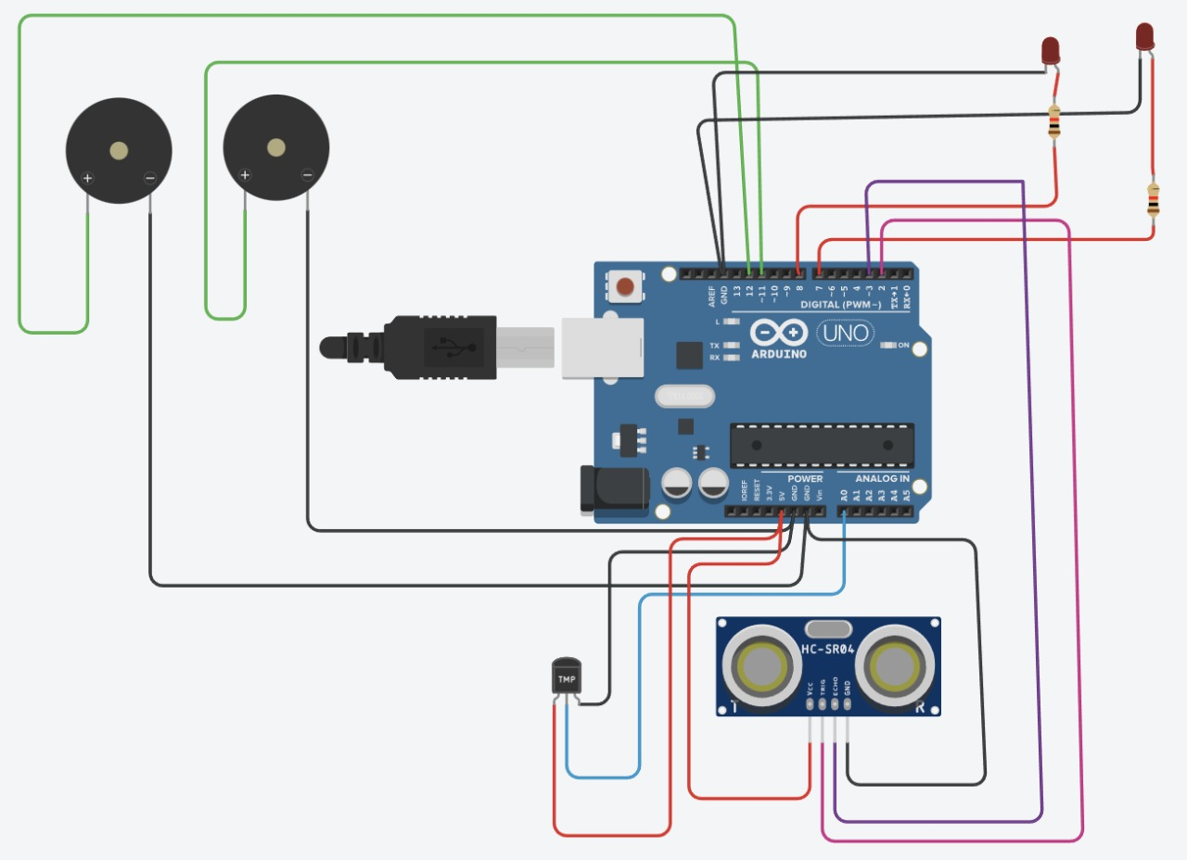

**Code:**

// C++ code

int t=2;

int e=3;

void setup()

{

Serial.begin(9600);

pinMode(t,OUTPUT);

pinMode(e,INPUT);

pinMode(12,OUTPUT);

}

void loop()

{

//ultrasonic sensor

digitalWrite(t,LOW);

digitalWrite(t,HIGH);

delayMicroseconds(10);

digitalWrite(t,LOW);

float dur=pulseIn(e,HIGH);

float dis=(dur*0.0343)/2;

Serial.print("Distance is: ");

Serial.println(dis);

//LED ON

if(dis>=60) //(in terms of centimeter)

{

digitalWrite(8,HIGH);

digitalWrite(7,HIGH);

}

//Buzzer For ultrasonic Sensor

if(dis>=60)

{

for(int i=0; i<=5; i=i+1)

{

tone(12,i);

delay(1000);

noTone(12);

delay(1000);

}

}

//Temperate Sensor

double a= analogRead(A0);

double t=(((a/1024)*5)-0.5)*100;

Serial.print("Temp Value: ");

Serial.println(t);

delay(1000);

//LED ON

if(t>=20) //(in terms of celsius)

{

digitalWrite(8,HIGH);

digitalWrite(7,HIGH);

}

//Buzzer for Temperature Sensor

if(t>=20)

{

for(int i=0; i<=5; i=i+1)

{

tone(12,i);

delay(1000);

noTone(12);

delay(1000);

}

}

//LED OFF

if(t<20)

{

digitalWrite(8, LOW);

digitalWrite(7, LOW);

}

}

**Output Serial Monitor:**